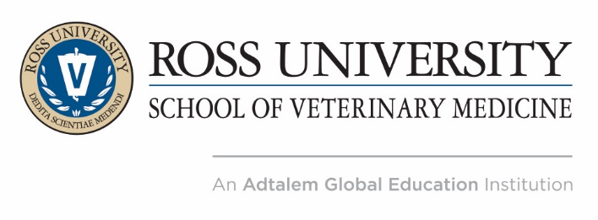

NEWS RELEASE
Media Contact
Megha Hamal
Megha.Hamal@adtalem.com
217-502-0901

Veterinary Professionals, Ross University School of Veterinary Medicine Alumni, and Veterinary Technicians from All Specialties Meet in St. Kitts to Discuss Equine Medicine, Veterinary Wellness and More

BASSETERRE, St. Kitts. – Oct. 31, 2017 – Veterinary professionals from all specialties, including Ross University School of Veterinary Medicine (RUSVM) alumni and veterinary technicians will meet at the West Indies Veterinary Conference hosted by RUSVM from Nov. 5-10, 2017, in St. Kitts. The conference will discuss new findings surrounding veterinary wellness, best practices surrounding exotics, small animal and equine medicine and an overview on technologies that are transforming veterinary practice, among many others.

Approximately 150 veterinary professionals are expected to attend this annual week-long conference. The conference provides a great opportunity for attendees to earn 56 hours of continuing education lectures within seven program areas, including small animals/pocket pets, exotics, equine medicine, wellness and more. In addition, the conference provides a platform for attendees to network with veterinary professionals, participate in a series of career building courses and join a hands on echocardiography wet lab experience that includes echocardiographic diagnoses.

“We are grateful to all of our speakers and educators who are contributing their time to share knowledge at the conference,” said Dr. Sean J. Callanan, dean at RUSVM. “I am confident that the conference will provide veterinarians, RUSVM faculty and alumni, academics and veterinary technicians the opportunity to attend lectures on topics such as critical care in companion animals, wellness, exotics, equine medicine and veterinary business management.”

“I am looking forward to delivering my keynote presentation on how to thrive in the veterinary profession at the West Indies Vet Conference,” said Dr. Mark Stetter, dean, College of Veterinary Medicine & Biomedical Sciences at Colorado State University. “I believe we are at a critical juncture and we must work together to solve the challenges ahead. We must look to positive solutions and share knowledge on ways we can improve the collective wellbeing of both animals and humans.”

Distinguished speakers and experts from Tufts University School of Veterinary Medicine, Cornell University Hospital for Animals and Auburn University College of Veterinary Medicine, will provide lectures and presentations on topics including, tactics to build a successful veterinary management, the nuts and bolts of practicing wellness in the veterinary profession, approaches to small animal medicine, and advances and trends in equine and small animal medicine, among others.

Members of the press are encouraged to visit the Media Resource page to access the official program, list of speakers, and photos from the conference.

About Ross University School of Veterinary Medicine
Ross University School of Veterinary Medicine (RUSVM) is a member of Adtalem Global Education (NYSE: ATGE), a global education provider headquartered in the United States. The organization's purpose is to empower students to achieve their goals, find success and make inspiring contributions to our global community. Founded in 1982, RUSVM is committed to preparing students to become members and leaders of the worldwide public and professional healthcare team and to advance human, animal and ecosystem health (One Health Initiative) through research and knowledge exchange. RUSVM has focused research programs with an emphasis on emerging infectious and zoonotic diseases, conservation medicine and ecosystem health. RUSVM offers postgraduate Masters’, Ph.D. and Doctor of Veterinary Medicine (DVM) programs accredited by the St. Christopher & Nevis Accreditation Board. The DVM program holds accredited status from the American Veterinary Medical Association (www.avma.org). The Ross Veterinary Clinic is accredited by the American Animal Hospital Association (www.aahanet.org). For more information about Ross, visit http://veterinary.rossu.edu/

About Adtalem Global Education
The purpose of Adtalem Global Education is to empower students to achieve their goals, find success and make inspiring contributions to our global community. Adtalem Global Education Inc. (NYSE: ATGE; member S&P MidCap 400 Index) is a leading global education provider, and the parent organization of Adtalem Educacional do Brasil, American University of the Caribbean School of Medicine, Association of Certified Anti-Money Laundering Specialists, Becker Professional Education, Carrington College, Chamberlain University, DeVry University and its Keller Graduate School of Management, Ross University School of Medicine and Ross University School of Veterinary Medicine. For more information, please visit adtalem.com.

